**Benefits of Hot and Cold Contrast Therapy Baths**

How Contrast Baths Are Used in Physical Therapy

By [Brett Sears, PT](https://www.verywellhealth.com/brett-sears-2695988)

Updated on May 03, 2024

 Medically reviewed by [Eva Umoh Asomugha, M.D.](https://www.verywellhealth.com/eva-umoh-asomugha-m-d-5078749)

Table of Contents

Table of Contents

* [How It Works](https://www.verywellhealth.com/contrast-bath-in-physical-therapy-2696628#toc-how-contrast-therapy-works)
* [Benefits](https://www.verywellhealth.com/contrast-bath-in-physical-therapy-2696628#toc-benefits-of-contrast-therapy-baths)
* [Possible Risks](https://www.verywellhealth.com/contrast-bath-in-physical-therapy-2696628#toc-risks-of-contrast-therapy)
* [At-Home Treatment](https://www.verywellhealth.com/contrast-bath-in-physical-therapy-2696628#toc-at-home-contrast-therapy-treatment)

Contrast therapy involves submerging an injured body part or your entire body into a hot bath and then a cold bath, switching back and forth, to improve circulation and muscle recovery.1 It is commonly used by [physical therapists](https://www.verywellhealth.com/what-is-a-physical-therapist-2696641) and [sports medicine specialists](https://www.verywellhealth.com/what-to-expect-from-pt-during-the-first-appointment-2696665) as a form of [whirlpool hydrotherapy](https://www.verywellhealth.com/water-exercise-routine-for-your-back-296860).2

Research has shown that contrast therapy can reduce [muscle fatigue](https://www.verywellhealth.com/muscle-weakness-5199929), [spasms](https://www.verywellhealth.com/what-causes-muscle-spasms-and-cramps-3120487), pain, swelling, and [lactic acid buildup](https://www.verywellhealth.com/lactic-acid-7092705) following intense exercise. It may help improve the [range of motion](https://www.verywellhealth.com/overview-range-of-motion-2696650) and [functional mobility](https://www.verywellhealth.com/assistance-with-mobility-in-physical-therapy-2696073) of joints like the knee, elbow, or hands.2

This article describes how contrast therapy works, including the benefits and risks. It also explains how to perform contrast therapy at home to recover from injury or manage conditions like arthritis.

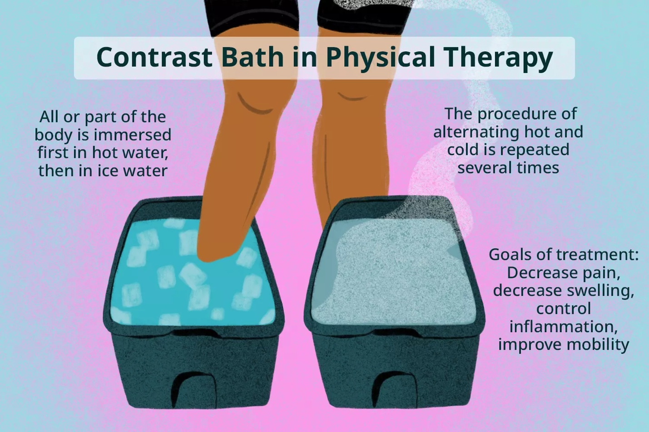

Verywell / Danie Drankwalter

How Contrast Therapy Works

Contrast therapy works by triggering physiological responses to heat and cold. It operates on the same principles of [thermotherapy](https://www.verywellhealth.com/thermotherapy-or-cryotherapy-for-osteoarthritis-2552270) (heat therapy) and [cryotherapy](https://www.verywellhealth.com/ice-or-heat-2548807) (cold therapy). Exposure to warmth causes blood vessels to dilate (widen) and exposure to cold causes them to constrict (narrow).3

Switching back and forth between warmth and cold creates a pumping action that may help decrease [inflammation](https://www.verywellhealth.com/signs-of-inflammation-4580526). This, in turn, can help alleviate pain and improve joint mobility.1

Contrast therapy is commonly used to recover from a soft tissue or joint injury but is also used by performance athletes to enhance post-exercise recovery. It can also be used to speed healing following [orthopedic surgery](https://www.verywellhealth.com/physical-therapy-cost-5194917).

Injuries that benefit from contrast bath treatments include:3

* [Ankle and leg fractures](https://www.verywellhealth.com/common-fractures-of-the-leg-ankle-and-foot-2696028)
* [Plantar fasciitis](https://www.verywellhealth.com/plantar-fasciitis-2549411)
* [Achilles tendonitis](https://www.verywellhealth.com/tendonitis-definition-causes-treatment-2696478)
* [Dislocated elbow](https://www.verywellhealth.com/dislocated-elbow-8383988)
* [Hand and finger arthritis](https://www.verywellhealth.com/finger-arthritis-2549393)
* [Torn meniscus](https://www.verywellhealth.com/meniscus-tear-treatment-2549649)
* [Anterior cruciate ligament (ACL) injuries](https://www.verywellhealth.com/acl-tears-overview-2549231)

Contrast therapy is typically performed in temperature-controlled whirlpool baths. The whirlpool action is thought to further promote muscle relaxation and ease pain.3

[Benefits of Whirlpool Therapy](https://www.verywellhealth.com/contrast-bath-in-physical-therapy-2696628)

How Contrast Therapy Is Performed

Depending on the facility, contrast therapy may involve two whirlpool baths, one hot and one cold, or one hot whirlpool bath and a cooling tub.

Once both tubs are at the correct temperature, the injured body part will be submerged in the heated water for three to four minutes.4 The physical therapist may also ask you to perform gentle-motion exercises (like wrist rotations or knee extensions) to increase joint mobility.

You will then submerge the body part in a cold whirlpool bath or tub for one minute.4 For this portion of the therapy, you will let the joint relax without movement.

This sequence is repeated back and forth for 20 to 30 minutes. Upon completion, you will rest for several minutes before evaluation by the physical therapist.

0 seconds of 1 minute, 35 secondsVolume 90%

1:35

**Click Play to Learn All About Contrast Baths for Physical Therapy**

This video has been medically reviewed by [Laura Campedelli, PT, DPT](https://www.verywellhealth.com/laura-campedelli-pt-dpt-4776034)

Benefits of Contrast Therapy Baths

The goals of contrast therapy differ based on whether you are recovering from an injury or surgery or using it to improve recovery during rigorous sports training.

Irrespective of the reason, contrast baths work by:3

* Decreasing muscle pain
* Decreasing joint stiffness and improving joint mobility
* Reducing swelling and [edema](https://www.verywellhealth.com/edema-overview-4580232) (fluid overload in tissues)
* Promoting circulation that can speed healing

For athletes, contrast baths can reduce [delayed onset muscle soreness (DOMS)](https://www.verywellhealth.com/delayed-onset-muscle-soreness-doms-7108703) caused by the buildup of lactic acid in muscles. By doing so, athletes can continue strict training programs without interruption.5

The current body of research tends to support the benefits of contrast therapy in physical therapy and sports medicine:

* A 2018 study in the *Journal of Athletic Training*examined the effects of contrast therapy using infrared spectroscopy and other tools, and confirmed that it promotes healing by increasing tissue oxygenation and decreasing tissue swelling and edema.6
* A 2014 study in the *Journal of Clinical Diagnosis and Research*reported that contrast baths may be as effective as [steroid injections](https://www.verywellhealth.com/steroid-injections-everything-you-should-know-190453) in reducing pain associated with plantar fasciitis.7
* A 2022 review of studies in *Cureus*suggests that contrast therapy is more effective in easing arthritis pain and stiffness than a hot bath alone. It also suggests that gentle vibration, such as that involved in whirlpools, blocks pain signals by stimulating mechano-receptors in the skin.3
* A 2022 case study in *Spinal Cord Series and Cases*reported that a 54-year-old male with severe nerve pain due to [multiple myeloma](https://www.verywellhealth.com/multiple-myeloma-overview-4586928) had a greater than 50% reduction in pain after daily contrast therapy, allowing him to sleep at night. This suggests that contrast therapy may have benefits in easing [neuropathic pain](https://www.verywellhealth.com/what-is-neuropathic-pain-2564614).8

[8 Common Physical Therapy Treatments](https://www.verywellhealth.com/physical-therapy-treatments-and-modalities-2696683)

Risks of Contrast Therapy

While generally considered safe, contrast therapy poses certain risks if performed incorrectly or inappropriately. These include:

* Scalding burns from water that is too hot2
* Increased bleeding if there are ruptured blood vessels on or inside the wound2
* Intense nerve pain in people with [peripheral neuropathy](https://www.verywellhealth.com/peripheral-neuropathy-3145943) from cold exposure9
* Increased pain from cold exposure in people with [peripheral vascular disease](https://www.verywellhealth.com/peripheral-artery-disease-1746093)4

At-Home Contrast Therapy Treatment

Contrast therapy can be performed at home with relatively simple tools, including two receptacles (like a bucket or tub) and a water thermometer to ensure the ideal, safe temperatures.

To keep the hot and cold baths at the correct temperatures, have a kettle of hot water and some ice to add if needed.

To start:4

1. Fill one basin with hot water (100 to 104 degrees F).3
2. Fill the other basin with cold water (46 to 50 degrees F).3
3. Dip the affected area in the hot water basin for three to four minutes.
4. Immediately switch to the cold water basin for one minute or as long as long as it can be tolerated.
5. Repeat the process three or four more times for a total of 20 minutes.

If the water in the cold basin gets above 50 F, add some ice.

If the water in the hot basin drops below 100 F, add a little hot water but *do not*continue if it goes above 104 F. Either allow it to cool down or add some ice.

You do not need special water for contrast therapy; plain tap water is fine.

Summary

Contrast therapy is used in physical therapy to reduce pain, improve joint mobility, and speed healing after a joint or soft tissue injury. It can also be used to enhance post-exercise recovery.

Contrast therapy involves submerging a body part in warm water for three to four minutes and then submerging it in cold water for one minute. The process is switched back and forth for a total of 20 to 30 minutes.

Contrast therapy is considered safe but may not be appropriate if there is bleeding on or below the skin or if you have severe peripheral neuropathy or peripheral artery disease.